Here are descriptions of different levels of reflective writing.

Transitions Skills and Strategies
Descriptive writing: Tells the story, often from one view point, and normally in the sequence that it happened with no reflection on meaning or impact.

Descriptive account with some reflection: is still focused on telling the story but it starts to include the possibility of
questions that could be asked.

Reflective writing: includes the telling of the story but external information, questioning of motives and clear reflection is included.

Navigating transitions:
Critical self-reflection

What is self-reflection?
Self-reflection comes from examining your learning experience, coming up with ideas to improve your performance and putting these ideas into practice.

What is critical self-reflection?
Critical self-reflection requires you to step back from your learning experience and engage in deeper and more meaningful learning. This can be helped by developing
self-reflection in your thinking and writing.

Further resources:
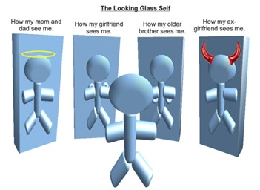

www.enhancementthemes.ac.uk/transition-skills-and-strategies

Further reading:
Dweck, C (2006): Mindset: the new psychology of success, Ballantine Books, ISBN: 9780345472328.
Booth, A (2001): Developing History Students' Skills in the Transition to University, Teaching in Higher Education, 6(4), pp 487-503.
This editable document has been specially designed to enable you to tailor content to your particular subject or department. QAA Scotland is therefore not responsible for any content changes made to the template.
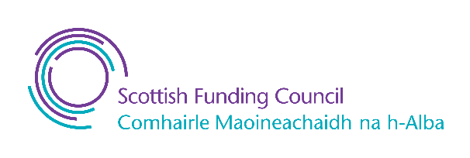

As writing becomes more reflective it shifts:
Remember:
- try to not treat reflective activities as extra work
- look for its relevance to your learning and you will remain motivated.

from description to reflective account
- from no questions to questions to responding to questions
- emotional influence is recognised, and then handled increasingly effectively
- there is a 'standing back from the event'
- there is a shift from self-questioning, challenge to own ideas
Some questions you can ask yourself

- What did you learn?
- How did you feel when you were learning?
- How can you apply the learning in the future?
- What were the barriers to learning?

- from recognition of relevance of prior experience
- in the taking into account of others’ views.

Top tips to help you to develop a learning journal
A learning journal can be a collection of learning experiences and reflection on them. It can be hand written or electronic.
Start with small steps
To begin with identify a learning experience which could be a lecture, video or discussion with another student.

Use a Journal Entry Template
A blank page can be very daunting but looking at examples of what other people have already done or using a template to guide you through the process can help.

Reflect more than once
Return to the journal entry at a later date to reflect for a second time on your learning experience.

