Transitions Skills and Strategies
Current levels of self-belief
To assess your current levels of self-belief, for each of the 10 statements below rate yourself on a scale of 1-10
(where 1 means you disagree strongly with the statement, and 10 means you strongly agree with it).
Question | Score
I am confident that I have the capability to learn course material this semester
I am confident that I will be able to solve problems in my subjects
I am confident I can manage demands on my time such as from essays, labs and tutorials
I am confident that, if I put in necessary effort, I can perform well
In a tutorial, I know I can put forward my ideas and suggestions
I might be nervous about the public speaking part of my course but I believe that I can perform well, for example, if I give myself enough preparation time
When I attend a new class, I can start up a conversation with other students
In addition to my academic tasks, I am confident that I can take the steps to develop myself for future employment
In my social life I am able to form and maintain friendships with others
I find it easy to form new friendships with peers
Total score

Published by QAA, and produced by the sector and QAA Scotland, this resource has been commissioned by the Scottish Funding Council to support its duty to secure provision for assessing and enhancing the quality of fundable further and higher education provision.
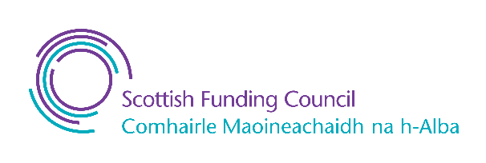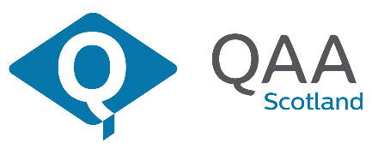

Published - 9 January 2023

© The Quality Assurance Agency for Higher Education 2023
Registered charity numbers 1062746 and SC037786
www.enhancementthemes.ac.uk

