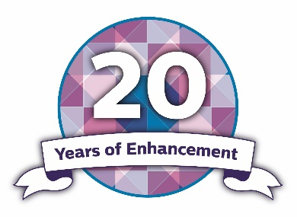

Transitions Skills and Strategies
Encouraging self-reflection

Identify two things that you did or habits that you developed that helped you to learn.
Things that worked well
1
2
How can you apply what worked before to your future learning experiences?
Identify two things that could have been better in your learning experience.
Things that worked less well
1
2
What were the barriers (the things that got in the way of you learning)?
How do you hold yourself back from learning?
Self-limiting behaviours
1
2
Based on your earlier responses, what could you do differently to make your ability to learn better in the future?
Things that could work well in the future
1
2

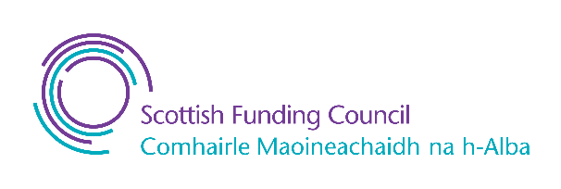Published by QAA, and produced by the sector and QAA Scotland, this resource has been commissioned by the Scottish Funding Council to support its duty to secure provision for assessing and enhancing the quality of fundable further and higher education provision.

Published - 9 January 2023

© The Quality Assurance Agency for Higher Education 2023
Registered charity numbers 1062746 and SC037786
www.enhancementthemes.ac.uk

