

'Gathering Together: working alongside students in an evidence-critical environment’

Annotated Select Bibliography

**Source**: Berg, Maggie and Seeber, Barbara (2016) *The Slow Professor: Challenging the Culture of Speed in the Academy*. Toronto: University of Toronto Press.

This little book has become a bit of a classic. It reminds us of the pleasures of pedagogy, the importance of collegiality and the importance of taking time to think. It’s a bit of mindfulness for the contemporary academic.

**Source**: Cook-Sather, Alison, Bovill, Catherine, and Felten, Peter (2014)*Engaging Students as Partners in Learning and Teaching: a Guide for Faculty*.  San Francisco: John Wiley & Sons.

This is an eminently practical book which works as a useful guide for setting up, improving and evaluating student-staff partnerships in higher education. It’s an accessibly-written text grounded in genuine experience and provides a very useful companion in student engagement adventures.

**Source**: Mercer-Mapstone, Lucy et al (2017) A systematic literature review of students as partners in higher education.  *International Journal for Students as Partners*, Vol.1, Issue 1.

This is a systematic literature review of research on students as partners in higher education, and is itself an example of partnership working, as it is co-produced by as student-staff team. It’s a very good place to start if you are looking for a way in.

**Source**: Macfarlane, Bruce (2018) Student academic freedom: do students at university have freedom to learn?  Prezi 2018.  https://prezi.com/omp6-lfftqtw/do-students-at-university-have-the-freedom-to-learn/

Although student engagement seems like it should be a ‘good thing’, it can be problematic once it becomes a proxy measure for aspects of institutional performance (such as teaching quality). Bruce Macfarlane has developed a reputation for challenging a bland acceptance of student engagement and this presentation explains some of his reasons for querying it.

**Source**: Ondaatje, Michael (1987) *In the Skin of a Lion*. London: Secker and Warburg.

This novel is set in Toronto in the first half of the twentieth century and focuses on the construction of two major landmarks, the Prince Edward viaduct and the Harris Waterworks. Ondaatje looks at the way migrant labour was used, and largely unrecognised, in the building of municipal Toronto. He also uses the process of construction as a metaphor for artistic process, and as a way of exploring the role of narrative in the construction of history.

**Source**: Quinlan, Kathleen M. (2016) How emotion matters in four key relationships in teaching and learning in higher education.  *College Teaching*, 64:3, p.101-111. DOI: 10.1080/87567555.2015.1088818

Quinlan’s paper discusses the emotional investment tutors and students make in an academic subject and in their teaching and learning communities. The affective dimension of teaching and learning relationships is under-theorised. This is an accessible discussion of how we might pay attention to the emotional aspects of our investment in our academic subjects and in our learning communities, and has a series of recommendations for small adjustments we can make in everyday practice.

**Source**: [HuMetricsHSS](http://humetricshss.org/about/)

The Humane Metrics Initiative has a helpfully descriptive subtitle, ‘Rethinking humane indicators of excellence in the humanities and social science’. The initiative outlines a set of values that should underpin any framework for evaluating ‘a scholarly life well-lived’. The values are collegiality, quality, equity, openness and community. The HuMetricsHSS blog explains the initiative clearly and it is a set of values that underpins ways of working alongside students and staff on co-design projects.

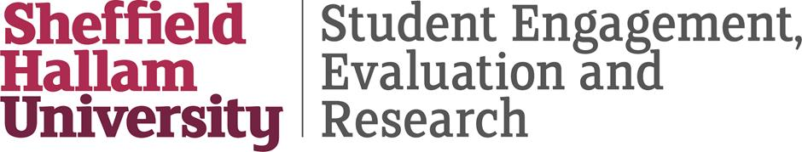

This document has been produced and published by Jill LeBihan of the Directorate of Student Engagement, Evaluation and Research at Sheffield Hallam University based on content provided by the Quality Assurance Agency for Higher Education (QAA). As such, this document may contain content that is not wholly endorsed by QAA.

