'Optimizing the use of Existing Evidence’

Beyond the metrics: identifying, evidencing and enhancing the less tangible assets of higher education

Dr Alastair Robertson, Director of Teaching and Learning Enhancement, Abertay University
Professor Elizabeth Cleaver, Director of Learning and Teaching, University of West of England
Dr Fiona Smart, Head of Learning and Teaching Enhancement, Edinburgh Napier University

Introduction
The international higher education sector has spent considerable resource trying to measure teaching quality. In the UK, an increased focus on accountability and regulation have been drivers using metric-based quantitative methodologies that rely on proxies such as student satisfaction (NSS), and graduate earnings (LEO). This is despite the fact that measuring teaching quality is recognised as a wicked problem- it does not simply boil down to numerical measures (for example, Gibbs, 2010). The conclusions of the multimillion pound HEFCE/ OfS “Learning Gain” initiative also concurred and questioned the robustness of such approaches. Not everything that is important and valued by higher education is easily measurable or quantifiable- HE has a number of so-called intangible assets.
Collaborative Cluster project: Beyond the metrics
This project was funded by QAA Scotland as part of the current national Enhancement Theme “Evidence for Enhancement”. A literature review accompanied by a series of participatory workshops were held across the UK involving academic and professional services staff, senior managers and student representatives, often tagged on to existing network meetings. The aims of the workshops were to consult participants on what aspects of a high quality student experience they felt were important, of high value and yet difficult to measure/ quantify.

Key Intangible Assets arising from this study

Looking across the outcomes of the workshops, the following priority intangible asset themes emerged:
      - Sense of belonging/ part of an (academic) community. Such students are more likely to complete their studies and achieve better outcomes- Thomas et al (2017).
      - Building effective relationships (between students and staff and between staff) also helps to foster strong learning communities (Thomas et al (2017).
      - The wider transformational impact of a university education on students. Activities that lie beyond core academic studies, and also the longer-term impact of a university education.
      - Wellbeing (of students and staff). Individuals are much more likely to be engaged, productive and successful if they have positive wellbeing and mental health.
      - Student engagement. Our participants defined this as students’ engagement and participation in their own learning but also the wider learning experience, sparqs (2012).

A novel Conceptual Model
We also developed a novel conceptual model and accompanying process based on cultural mapping (Duxbury (2016)) to help institutions identify, analyse the value of and enhance their intangible assets. Our model is termed an “Evidencing Value Framework” and comprises four quadrants (resources; core educational and support components; ethos, cultures and identities; systems and structures). It can be applied at various levels: micro (e.g. programme), meso (e.g. departmental/ service) and macro (institutional or faculty/ school/college) meaning that it is sufficiently flexible and holistic for various contexts.
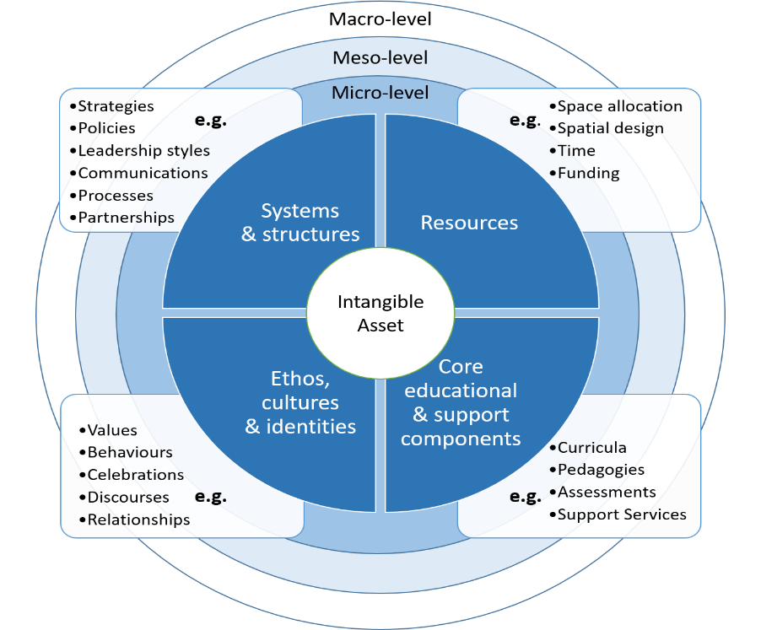
Possible uses
The model and resources developed by the project have been designed to assist with preparing for quality reviews, curriculum reform, strategy development, TEF submissions etc. If you are interested in and using these tools, we want to hear from you!

References
Duxbury, N & Longley, A. (2016). https://www.sciencedirect.com/journal/city-culture-and-society/vol/7/issue/1
Gibbs, G (2010) https://www.heacademy.ac.uk/system/files/dimensions_of_quality.pdf
Sparqs (2012) https://www.sparqs.ac.uk/upfiles/SEFScotland.pdf
Thomas, L., Hill, M., O’Mahony, J., Yorke, M., (2017). https://www.heacademy.ac.uk/knowledge-hub/supporting-student-success-strategies-institutional-change
This document has been produced and published by Abertay University, University of West of England and Edinburgh Napier University based on content provided by the Quality Assurance Agency for Higher Education (QAA). As such, this document may contain content that is not wholly endorsed by QAA.

