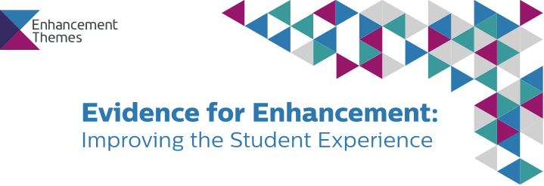

'Optimizing the use of Existing Evidence’

The power of learning analytics to impact learning and teaching: a critical perspective

Introduction
Teaching and learning is inevitably complex, in particular when learners and teachers are geographically at different locations. Building on his webinar presentation ‘The power of learning analytics to impact learning and teaching: a critical perspective’, Professor Bart Rienties has drafted four key findings from his research team using learning analytics at the Open University, who have been developing, testing, implementing, and evaluating learning analytics since 2014. These studies often use large datasets from hundreds of modules, thousands of students, and have been tested across a range of disciplines, levels, and academic years. Tips as to how teachers can use these research findings into their daily practice are highlighted in bold.

Learning design is essential for learning analytics
- Learning design is key to understanding learning processes and learning outcomes: 68% of weekly engagement by students is determined by how teachers design their courses (Nguyen, Rienties, Toetenel, Ferguson, & Whitelock, 2017; Rienties & Toetenel, 2016). Teachers can actively encourage students to engage by their design decisions, and can have a significant impact on retention. A study amongst 111.256 students showed that a 1% increase in communication activities in learning design (i.e., student to student, staff to student, student to staff) led to 0.5% increase in retention. Improve sign-posting to students and teachers about the expected learning design, and strive for learning activities related to communication.

Active use of predictive learning analytics improves retention
- Active use of learning analytics (e.g., OU Analyse) by teachers leads to a 2-5% increase in retention (Herodotou et al., 2017; Herodotou, Rienties, Verdin, & Boroowa, 2019; Rienties et al., 2017) Therefore, there is a strong need to convince teachers to actively use learning analytics.

Student satisfaction is unrelated to academic performance
- Student satisfaction (as expressed in Student Evaluation surveys) are important, but unrelated to academic performance and retention (Li, Marsh, Rienties, & Whitelock, 2017; Ullmann et al., 2018). Therefore, focus on designing courses that lead to retention rather than ‘happy students’, and hire and reward teachers not on student satisfaction scores but on retention.
- Student responses to surveys are substantially biased: some groups of learners are more (e.g., women, highly educated) or less (e.g., men, low educated, disabled students) likely to respond to surveys, or to write written comments (Ullmann et al., 2018). Teachers need to think about a broader reach and complex understanding of who is saying what, and whether all student voices are actually heard.

Herodotou, C., Rienties, B., Boroowa, A., Zdrahal, Z., Hlosta, M., & Naydenova, G. (2017). Implementing predictive learning analytics on a large scale: the teacher's perspective. Paper presented at the Proceedings of the Seventh International Learning Analytics & Knowledge Conference, Vancouver, British Columbia, Canada.
Herodotou, C., Rienties, B., Verdin, B., & Boroowa, A. (2019). Predictive Learning Analytics 'At Scale': Guidelines to Successful Implementation in Higher Education. Journal of Learning Analytics, 6(1), 85-95.
Li, N., Marsh, V., Rienties, B., & Whitelock, D. (2017). Online learning experiences of new versus continuing learners: a large scale replication study. Assessment & Evaluation in Higher Education, 42(4), 657-672. doi: 10.1080/02602938.2016.1176989
Nguyen, Q., Rienties, B., Toetenel, L., Ferguson, F., & Whitelock, D. (2017). Examining the designs of computer-based assessment and its impact on student engagement, satisfaction, and pass rates. Computers in Human Behavior, 76(November 2017), 703-714. doi: 10.1016/j.chb.2017.03.028
Rienties, B., Clow, D., Coughlan, T., Cross, S., Edwards, C., Gaved, M., . . . Ullmann, T. (2017). Scholarly insight Autumn 2017: a Data wrangler perspective. Milton Keynes: Open University.
Rienties, B., & Toetenel, L. (2016). The impact of learning design on student behaviour, satisfaction and performance: a cross-institutional comparison across 151 modules. Computers in Human Behavior, 60, 333-341. doi: 10.1016/j.chb.2016.02.074
Ullmann, T., Lay, S., Cross, S., Edwards, C., Gaved, M., Jones, E., . . . Rienties, B. (2018). Scholarly insight Spring 2018: a Data wrangler perspective. Milton Keynes: Open University.

This document has been produced and published by The Open University based on content provided by the Quality Assurance Agency for Higher Education (QAA). As such, this document may contain content that is not wholly endorsed by QAA.

