'Just enough? Why we need to question our assumptions about evidence'
Constructing a 'new order' of evidence

Dismantling the pyramid 'hierarchy' of evidence

In the webinar, discussion centred on the contested nature of evidence and the role of methodology in educational decision-making, with particular focus on what constitutes as being ‘credible’. Prior to constructing their own models of evidence, participants were invited to critically appraise the usefulness of traditional models that favour experimental research approaches, such as the one presented below:
In this pyramid model, experimental research approaches, such as randomised controlled trials, are positioned at the top and deemed to be the 'gold standard of evidence'. Further down the pyramid are non-experimental forms of research, such as case studies. At the bottom of the pyramid are types of evidence which are considered to be unscientific and untested, such as ideas taken from professional practice.

Considering alternative ideas and models
Before constructing your own 'new order' model of evidence, you may wish to consider other suggestions that have been proposed in educational research:
Nelson and Campbell (2017) use the term evidence-informed practice to describe the integration of professional judgement, system-level data, classroom data and research evidence. These scholars argued that a range information and knowledge are required to address the complex challenges in education.

Levin (2013) developed this conceptual framework to explain how the mobilisation of knowledge is connected through structural, organisational and personal connections. This requires interaction and collaboration between the producers of knowledge, the users of knowledge and those involved in connecting research and practice.

Constructing a 'new order' of evidence
Use the space at the bottom of the page to create your own model of evidence. Please reflect on the examples that have been used in the webinar. Think about the range of sources of knowledge and evidence that you draw upon to examine not only what works in your practice but why, where and how it works. Is there any fusion of process-based approaches with traditional forms of evidence?
Consider the role of: practitioner knowledge; professional and personal values; contextual factors (for example, the characteristics of students); quantitative research approaches (for example, randomised controlled trials and non-experimental studies); qualitative research approaches (for example, action research, observations and case studies); and mixed-method approaches.

We would love to see your 'new order' model and hear about how you use evidence for enhancement purposes. Please email your creations and further thoughts to Stella Jones-Devitt (s.jones-devitt@shu.ac.uk) and Alan Donnelly (a.donnelly@shu.ac.uk)

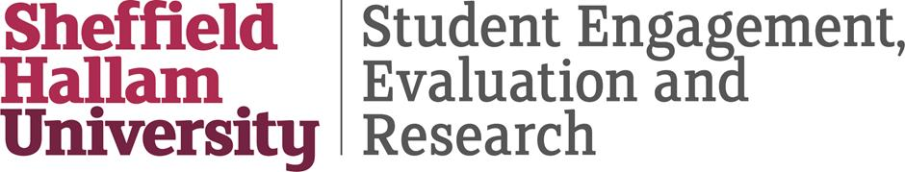
This document has been produced and published by Stella Jones-Devitt and Alan Donnelly of the Directorate of Student Engagement, Evaluation and Research at Sheffield Hallam University based on content provided by the Quality Assurance Agency for Higher Education (QAA). As such, this document may contain content that is not wholly endorsed by QAA.

