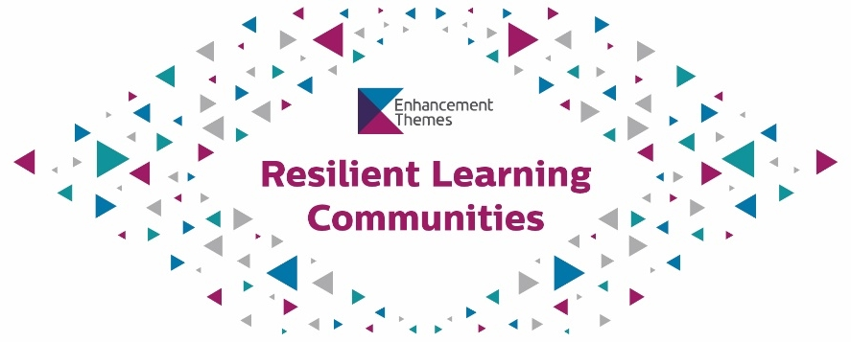

Call for expressions of interest

The Anti-Racist Curriculum Project: Piloting and evaluating resources developed in Phase 1
Building on the sector-wide commitment to tackle racism in Scottish higher and further education, QAA Scotland and AdvanceHE are working together with the tertiary sector to develop and curate resources, learn from current practice, and recognise best practice both in Scotland and beyond.

Phase 1 (2020-21)
Phase 1 of the project (2020-21) was funded by the Scottish Funding Council (SFC) and managed by AdvanceHE, building on the excellent work of the SFC-funded Tackling Racism on Campus project. Four priority areas were identified:

- Terms of inclusion
- Current and best practice
- Curriculum considerations
- Student and staff experience.
Phase 1 resulted in a range of resources, created by a cross-sector Working Group, which you can find on the AdvanceHE website. The resources constitute a guide to getting started on this vital work, and include considerations of language, curriculum development, approaches to teaching, student engagement, allyship and more.

Phase 2 (2021-22)
Phase 2 of the project (2021-22) will be managed by QAA Scotland as a major component of the current Enhancement Theme, Resilient Learning Communities. The aims of Phase 2 are:

- To facilitate discussions about developing anti-racist curricula in particular discipline areas (arts, humanities and social sciences; science, technology, engineering and maths; medicine, dentistry, nursing, midwifery, and allied healthcare);
- To facilitate discussions with a network of academic developers across a range of providers;
- To share practice and develop resources based on the above discussions;
- To pilot and evaluate resources produced in Phase 1;
- To make recommendations for the continuation of the project in 2022-23.

About the Enhancement Theme
Enhancement Themes aim to improve the learning experience of students studying within the Scottish higher education sector. The sector achieves this by identifying and agreeing a specific area to work on (known as a Theme). The Themes encourage higher education institutions (HEIs), staff and students to work together to develop new ideas and models for innovation in learning and teaching. Each Theme also allows the sector to share and learn from current and innovative national and international practice.

The 2020-23 Theme is Resilient Learning Communities. This Theme will focus on meeting the changing needs and values of an increasingly diverse student community in a rapidly changing external environment.

Enhancement Themes are intentionally broad, allowing HEIs and students’ associations to support projects that align with their strategic priorities. Alongside institutional work, QAA Scotland manages sector-wide projects. The Anti-Racist Curriculum will be a key sector-wide project managed by QAA Scotland as part of Resilient Learning Communities.

Piloting and evaluating resources developed in Phase 1
QAA Scotland invites expressions of interest from individuals interested in supporting the Anti-Racist Curriculum Project by piloting and evaluating the resources developed in Phase 1.

Required activities and outputs
- Design and plan activities aimed at evaluating each of the resources in the Guide, in keeping with the evaluation of the wider Enhancement Theme
- Deliver the planned activities, engaging with students and staff at a range of higher and further education institutions
- Write up the findings of these activities
- Provide regular reports to QAA Scotland on progress
- Attend (or otherwise report to) meetings of the project Executive Group and the Theme Leaders Group
- Proactively seek opportunities to promote and disseminate the resources, such as attendance at conferences (including the 2022 Enhancement Conference) and events.
QAA Scotland will provide support to the contracted individual. Such support may include:

- Guidance relating to the evaluation of the wider Enhancement Theme
- Introductions to institutional staff and students
- Support with promoting and disseminating the resources.
Dr Alison Eales (a.eales@qaa.ac.uk) will be the main point of contact.

Required skills, knowledge and experience
Applicants must be able to provide strong evidence of the following:

- An understanding of the importance of developing anti-racist approaches in higher and further education
- Evaluative skills; experience of measuring change and impact
- Research skills; familiarity with qualitative and quantitative methods, analysis, and research ethics
- Communication skills; experience of writing up research findings and presenting these to non-specialist audiences
- Organisation and time management skills; the ability to work alone and produce high quality work to deadline.

This work may suit a postgraduate research student. Residence in Scotland is not essential, but the successful applicant may have to demonstrate that they are legally entitled to work in the UK (please refer to government guidance as necessary).

Fee

The fee for this work will be £2040, calculated on the basis of six days’ work at a daily rate of £340.

The fee is inclusive of VAT, travel and subsistence, and will be paid in instalments upon satisfactory progress in delivering the work.
Application process and timeline

Please complete the application form provided in Appendix 1 and send to ARCadmin@qaa.ac.uk no later than 1700 GMT on 14 January 2022. Expressions of interest submitted in any other format, or after the deadline, will not be considered.

Applications will be assessed and scored by a team from QAA Scotland based on the strength of the evidence relating to the required skills, knowledge and experience and the proposed approach to the work.

The timeline for the project is as follows:

Activity | Deadline
Application deadline | 14 January 2022
Applications assessed and scored | 21 January 2022
Successful applicant notified | 24 January 2022
Contract issued | 4 February 2022
Interim reporting deadlines will be incorporated into the contract
once agreed between the successful applicant and QAA Scotland

Final report received | 30 June 2022

Get in touch
For more information, or if you have any questions, please email ARCadmin@qaa.ac.uk.

Appendix 1: Application Form

Contact details
Title
Name
Preferred pronouns
E-mail address
If you would prefer that we use an alternative contact method, or have any accessibility requirements in relation to this application, please indicate here.

Skills, knowledge and experience
Please use the table below to provide evidence of your skills, knowledge and experience in each of the following areas. Please do not exceed 500 words in any one box.

An understanding of the importance of developing anti-racist approaches in higher and further education
Evaluative skills; experience of measuring change and impact
Research skills; familiarity with qualitative and quantitative methods, analysis, and research ethics
Communication skills; experience of writing up research findings and presenting these to non-specialist audiences
Organisation and time management skills; the ability to work alone and produce high quality work to deadline

Your approach to piloting and evaluating the resources
Please summarise here your initial thoughts about how you would approach this work. We are not looking for a detailed project plan, but rather a sense of how you would engage with stakeholders (staff and students), what kind of activities you would plan and deliver, and how you would analyse and present your findings.

We strongly recommend that you refer to the Evaluation of the Enhancement Themes webpage in completing this section.

Please do not exceed 500 words in this box.

Data protection statement
All of the information collected in this form is necessary for the process of contracting for the work required. We will use the information provided by you on this form for these purposes only. We will treat all personal information with the utmost confidentiality and in line with current data protection legislation.

© The Quality Assurance Agency for Higher Education 2021
18 Bothwell Street, Glasgow G2 6NU
Registered charity numbers 1062746 and SC037786

Tel: 0141 572 3420
Web: www.enhancementthemes.ac.uk

