

'Data delving: Engaging Staff in Student Experience Data'

Case Study: The University of Magic Enterprise

The University of Magic Enterprise (UME) workshop is used to create a safe and non-judgemental space for staff to develop their understanding of how to use the National Student Survey (NSS) effectively for enhancement of the student experience.

The UME workshop used fictionalised data in a replicated version of Sheffield Hallam University reporting tools for both the quantitative (Image 1) and qualitative (Image 2) elements of the NSS. A fictional university was used so participants could develop their skills without feeling the need to justify their own faculty, department or course results. This 'alternative reality' was crucial for building staff confidence in an empowering and positive environment.

#### Image 1 - Example of NSS Quantitative Report

#### Image 2 - Example of NSS Qualitative Report

In groups, participants used the fictionalised reports to respond to a series of scenarios (see below). Each scenario is written from a different staff perspective from within the UME. This allowed participants to develop an understanding of how different stakeholders engage with the NSS. The scenarios had a list of broadly similar questions that helped each group interrogate the data in various reports. Each group was asked to write a short narrative of findings and outline three actions. These were presented back to the rest of the workshop participants. Each presenting group was asked to respond to any questions about their findings.

The UME workshop enabled participants to

* Develop their confidence in using survey data for enhancement
* Familiarise themselves with the university’s reporting tools
* Work collaboratively with colleagues
* Enhance their skill set

# Scenario 1: Faculty Senior Management Team

As a Faculty Senior Management Team, you have been requested to report the key findings from this year's student surveys to the University Leadership Team. You will need to present a short narrative with key findings and three actions.

## You might want to consider

* Institutional data; what do we need to know about UME's positioning?
* What does the subject data tell you, and what comparisons and conclusions can and should be drawn?
* At what level would you report on your data (course, department, or faculty)?
* What does the trend data tell you about your faculty?
* Do the "bank" questions give you any additional insight into the student experience?
* Would you include any equality trends in your report?
* Do the response breakdowns provide any more insight into your key findings?
* What insight do your student comments provide?

# Scenario 2: Head of Department

As Head of Department, you have been requested to report the key findings from this year's student surveys to the Faculty Senior Management Team. You will need to present a short narrative with key findings and three actions.

## You might want to consider

* Institutional data; what do we need to know about UME's positioning?
* What does the subject data tell you, and what comparisons and conclusions can and should be drawn?
* At what level would you report on your data (course, department, or faculty)?
* What does the trend data tell you about your department?
* Do the "bank" questions give you any additional insight into the student experience?
* Would you include any equality trends in your report?
* Do the response breakdowns provide any more insight into your key findings?
* What insight do your student comments provide?

# Scenario 3: Teaching Excellence Framework (TEF)

You have been requested to report the key findings in relation to the TEF metrics (teaching, assessment and feedback, academic support) from this year's student surveys at a Departmental meeting. The meeting will include senior management and academic staff responsible for learning and teaching and quality enhancement. You will need to present a short narrative with key findings and three actions.

## You might want to consider

* Institutional data; what do we need to know about UME's positioning?
* What does the subject data tell you, and what comparisons and conclusions can and should be drawn?
* At what level would you report on your data (course, department, faculty, institution)?
* What does the trend data tell you about your department?
* Do the "bank" questions give you any additional insight into the student experience?
* Would you include any equality trends in your report?
* Do the response breakdowns provide any more insight into your key findings?
* What insight do your student comments provide?

# Scenario 4: Course Teams

As a Course Team you have been requested to report the key findings from this year's student surveys to the Head of Department. You will need to present a short narrative with key findings and three actions.

## You might want to consider

* Institutional data; what do we need to know about UME's positioning?
* What does the subject data tell you, and what comparisons and conclusions can and should be drawn?
* How does the course results compare with other courses, is this a valid comparison?
* At what level would you report on your data (course, department, faculty, institution)?
* How will you engage module teams in enhancing the student experience in a meaningful way?
* What does the trend data tell you about your course?
* Do the "bank" questions give you any additional insight into the student experience?
* Would you include any equality trends in your report?
* Do the response breakdowns provide any more insight into your key findings?
* What insight do your student comments provide?

# Scenario 5: Course Teams - Closing the Feedback Loop

As a course team you have been requested to report the key findings from this year's student surveys at a staff/student forum. You will need to present a short narrative with key findings and three actions.

## You might want to consider

* Institutional data, what do we need to know about UME's positioning?
* What does the subject data tell you, and what comparisons and conclusions can and should be drawn?
* How does the course results compare with other courses, is this a valid comparison?
* At what level would you report on your data (course, department, or faculty, institution)?
* How will you engage module teams in enhancing the student experience in a meaningful way?
* What does the trend data tell you about your course?
* Do the "bank" questions give you any additional insight into the student experience?
* Would you include any equality trends in your report?
* Do the response breakdowns provide any more insight into your key findings?
* What insight do your student comments provide?

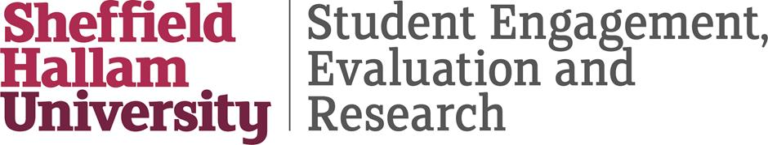

This document has been produced and published by Nathaniel Pickering of the Directorate of Student Engagement, Evaluation and Research at Sheffield Hallam University based on content provided by the Quality Assurance Agency for Higher Education (QAA). As such, this document may contain content that is not wholly endorsed by QAA.

