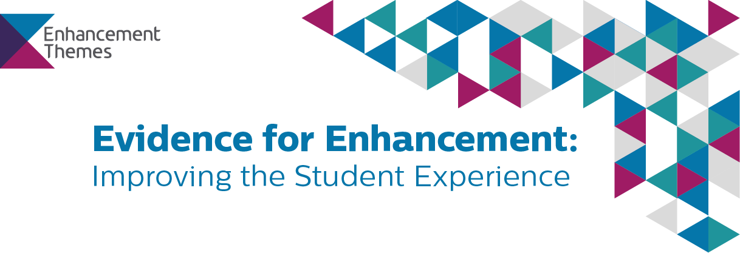
QAA SCOTLAND ENHANCEMENT THEME RESOURCES
Road-testing resources feedback template
Thank you for using resources produced as part of the Evidence for Enhancement Theme 2017-2020 and for agreeing to share with us your thoughts on these. The feedback you provide in response to these questions will be used in three ways:
- To help QAA Scotland structure any revisions and refinements of the materials you have tested and related or similar resources.
- To provide the substance of a case study to be hosted on the Enhancement Themes website and included in QAA Scotland presentations and other printed materials.
- To provide short testimonials which can be used by QAA Scotland in describing the resources and the impact they can have, in presentations, on social media, and in print.
Because we want to use the feedback to construct case studies and testimonials, your responses will not be anonymous.
Name | Role | Affiliation

Name of resource

What’s the background to your work?
Here you should describe the activity/project in which you used the resource. You could structure your response by answering the following questions:
- What were you doing?
- Why is this work important to you, your colleagues, and your students? What difference were you trying to make to the student experience?
- Who was involved?
- What did you want to achieve, and why is this important? How were you measuring success or impact?

How have you been using the resource?
Here you should describe how you used the resources as part of your work. You could structure your response by answering the following questions:
- How did you use the resource(s) (e.g. in a workshop, to refine a policy, to design an intervention, etc)?
- Why did you think they would help you/your colleagues/students?
- What did you want to achieve using the resource? Did you achieve this?
- In what ways did the resource(s) help with this?
- What would you say are the main benefits of using the resource(s) in this context?
- What would you say are the main challenges?

What has been the impact?
Here you should offer a summary of what you see as the impact of using this resource. You could structure your response by answering the following questions:
- How would you summarise the impact of this resource on you/colleagues/students? [Might be some overlap with answers above…]
- Did using the resource change the way you think about your work or the way you do things?
- What impact has/will it have on student experience?
- Is this a resource you will return to?
- Are there other contexts in which you might engage with these resources?

What would you change?
Here you should make any suggestions you have for improving the content and presentation of the resources. How could we make them more effective?
- How would you change the resource?
- What would you add?
- What would help you use it more effectively?

Testimonial: What would you say to others?
Could you sum up your experience of using the resource in a few sentences?

Thank you for taking the time to provide responses to these questions. The information you have provided will be used by QAA Scotland to improve the resources we produce and to create case studies and testimonials that will help us reach a wider audience with our work.

If you have any questions or concerns, please get in touch with us at ARCAdmin@qaa.ac.uk

